**Requirement Gathering and Analysis Phase**

**Technology Stack (Architecture & Stack)**

|  |  |
| --- | --- |
| Date | 25-06-2024 |
| Team ID | LTVIP2025TMID55102 |
| Project Name | Project – House Hunt |
| Maximum Marks | 4 Marks |

**Technical Architecture:**

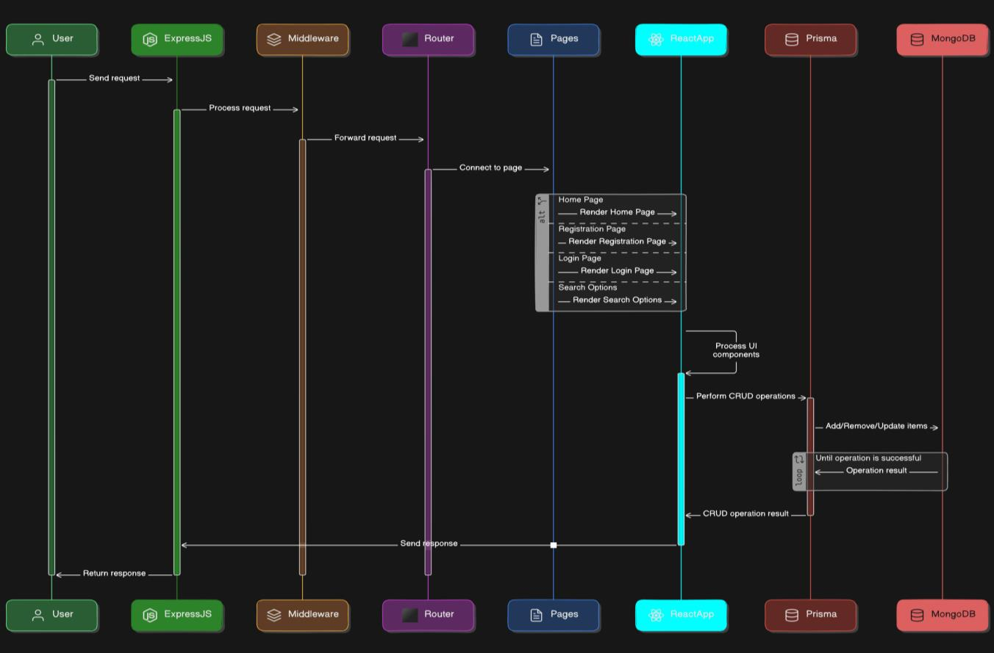

**Table-1 : Components & Technologies:**

|  |  |  |  |
| --- | --- | --- | --- |
| **S.No** | **Component** | **Description** | **Technology** |
| 1. | User Interface | Users can search for homes, register, log in, and manage their saved homes using this web application. | HTML, CSS, JavaScript / React Js etc. |
| 2. | API Gateway | Requests for APIs are routed to the relevant backend services via a single point of entry from the user interface. | Cloud-based API Gateway service |
| 3. | Search Service | backend service that searches the user's database for suitable house listings and returns the results. | Node.js with MongoDB |
| 4. | Listing Service | home publishing functionalities are managed by a backend service (create, update, delete listings). | Node.js with MongoDB |
| 5. | Database | retains all application data, including stored homes, user data, and house listings. | MongoDB |
| 6. | Geolocation Service | service that uses user location data to customize search results, provided the user gives permission. | Google Maps |
| 7. | User Service | Backend service for managing user profiles, logins, and registrations. | Node.js with MongoDB |
| 8. | Cloud Storage | Retailers posted pictures of their homes in order to save money and be scalable. | Cloudinary |
| 9. | Messaging Service | Backend service that makes it easier for users and landlords to communicate in real time. | Node.js |

**Table-2: Application Characteristics:**

|  |  |  |  |
| --- | --- | --- | --- |
| **S.No** | **Characteristics** | **Description** | **Technology** |
| 1. | Open-Source Frameworks | Dynamic user interfaces, reliable backend support, scalable data storage, type-safe database interactions, and interactive maps for property locations are all made possible by open-source frameworks. | Prisma, Express.js, React.js |
| 2. | Security Implementations | Protect user information and restrict access to different areas such as user profiles and house listings. | bcrypt ,JSON web tokens(JWT),  Middleware-Token Verification, Role Based Access |
| 3. | Scalable Architecture | helps to ensure that the application runs smoothly even during periods of high traffic by enabling it to adjust to a rising user base and data volume. | MongoDB, RESTful API, Node.js |
| 4. | Availability | reduces downtime and ensures that consumers may always use the house hunt services. | Multiple Node.js instances |
| 5. | Performance | provides quick response times for listing details, house searches, and other features, making the user experience seamless. | Prisma ORM, MongoDB, Node.js, Express |